Homework Summary

Student ID | 109590041 | Student Name | 范遠皓
Estimated Time | ___20__ hours
Time Log | Time spent in writing program  - From 19 : 00 to 24 : 00 12/31 ~ 1/1  Time spent in writing document  - From : to :  - From : to :
Actual Time | ___5__ hours
Difference between Estimated time and Actual Time | _____ hours (|Estimated Time – Actual Time|)  _____ % (|Estimated Time – Actual Time|/ Estimated Time)
Difficulty of the homework
Other Issues | 無

Dr.smell
DrawingApp 的 MainPage 產生的檔案無法消除。
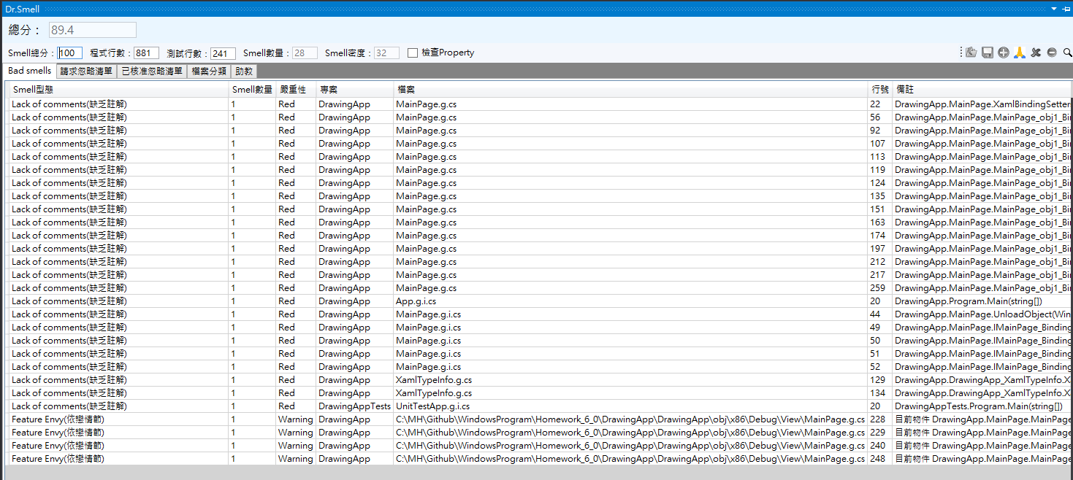
DataBinding
DrawingForm
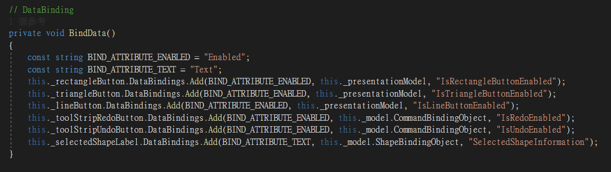
元件 | 屬性
矩形按鈕 | Enabled
三角形按鈕 | Enabled
畫線按鈕 | Enabled
redo按鈕 | Enabled
undo按鈕 | Enabled
選擇圖形標籤 | Text

DrawingApp MainPage
元件 | 屬性
矩形按鈕 | Enabled
三角形按鈕 | Enabled
畫線按鈕 | Enabled
redo按鈕 | Enabled
undo按鈕 | Enabled
選擇圖形標籤 | Text

